Total Revenue

SELECT SUM(total_price) AS Total_Revenue FROM pizza_sales

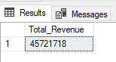

Average Order Value

SELECT SUM(total_price) / COUNT(DISTINCT order_id) AS Average_Order_value FROM pizza_sales



Total Pizza Sold

SELECT SUM(quantity) AS Total_Pizza_Sold FROM pizza_sales



Total Order

SELECT COUNT(DISTINCT order_id) AS Total_Order FROM pizza_sales



Average Pizza Sold

SELECT CAST(CAST(SUM(quantity) AS DECIMAL(10,2)) /

CAST(COUNT(DISTINCT order_id) AS DECIMAL(10,2)) AS DECIMAL(10,2)) AS Average_Pizza_Sold FROM pizza_sales



Total Order Per Day

SELECT DATENAME(DW, order_date) AS order_day, COUNT(DISTINCT order_id) AS Total_Order

from pizza_sales

GROUP BY DATENAME(DW, order_date)

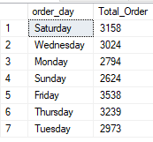

Total Order Per Month

SELECT DATENAME(MONTH, order_date) AS Month_Name, COUNT(DISTINCT order_id) AS Total_Order

from pizza_sales

GROUP BY DATENAME(MONTH, order_date)

ORDER BY Total_Order DESC

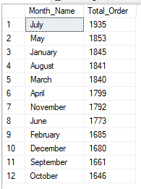

Total Sales

SELECT pizza_category, SUM(total_price) * 100 / (SELECT SUM(total_price) FROM pizza_sales)

AS Total_Sales

FROM pizza_sales

GROUP BY pizza_category

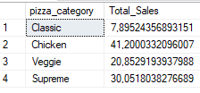

Total Pizza Size Sales

SELECT pizza_size, SUM(total_price) AS Total_Sales, CAST(SUM(total_price) * 100 /

(SELECT SUM(total_price) FROM pizza_sales) AS DECIMAL (10,2)) AS PCT

FROM pizza_sales

GROUP BY pizza_size

ORDER BY PCT DESC

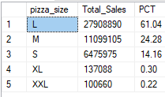

Top 5 Pizza Revenue

SELECT TOP 5 pizza_name, SUM(total_price) AS Total_Revenue

FROM pizza_sales

GROUP BY pizza_name

ORDER BY Total_Revenue DESC

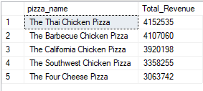

Bottom 5 Pizza Revenue

SELECT TOP 5 pizza_name, SUM(total_price) AS Total_Revenue

FROM pizza_sales

GROUP BY pizza_name

ORDER BY Total_Revenue ASC

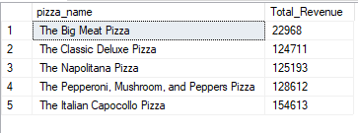

Top 5 Quantity Sales

SELECT TOP 5 pizza_name, SUM(quantity) AS Total_Quantity

FROM pizza_sales

GROUP BY pizza_name

ORDER BY Total_Quantity DESC

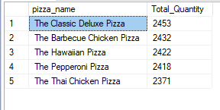

Bottom 5 Quantity Sales

SELECT TOP 5 pizza_name, SUM(quantity) AS Total_Quantity

FROM pizza_sales

GROUP BY pizza_name

ORDER BY Total_Quantity ASC

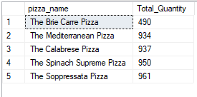

Top 5 Pizza Order

SELECT TOP 5 pizza_name, COUNT(DISTINCT order_id) AS Total_Orders

FROM pizza_sales

GROUP BY pizza_name

ORDER BY Total_Orders DESC

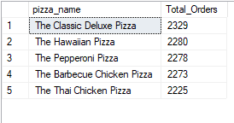

Bottom 5 Pizza Order

SELECT TOP 5 pizza_name, COUNT(DISTINCT order_id) AS Total_Orders

FROM pizza_sales

GROUP BY pizza_name

ORDER BY Total_Orders ASC

